

**American International University- Bangladesh**

**CSC 2209: Object Oriented Programming 1 (JAVA)**

**CO1 Evaluation**

**Project Summary Report**

**Fall 2019-20**

**Project Title: Online Maid Service**

|  |  |
| --- | --- |
| Student Name | Student Id |
| Hossain, Shahriar | **17-34702-2** |
| Alam, Rifat Bin | **17-34529-2** |
| Mahamud, Md Farah Al | **17-33502-1** |

**Introduction:**

By nature human being always find better solution like this finding maid on online is more Convincing way then the existing way for this we just want a application that’s called our Application *“***Online maid Service***”.* In this recent time there has no existing online maid service system working in our area or country. But like every problem there are always have easy or complex solution. Like complex solution, there is also some way to find a maid such as,

* Collect information from maid
* Collect information from neighbors
* Go to the specific area

The admin will manage the user, maid of this system. User can search maid. Desktops, laptops or android device and internet are very common these days. Almost in every house, there is at least one desktop or laptop and everyone has an android device. That is why we are create for a web base application. We are focusing more on technology to reduce maid problem and to create a better experience.

**User Category:**

There are three types of Users here. They are:

* Admin
* User
* Maid

**Feature List:**

In this project the “Admin” has the following features:

* Can view user and maid information
* Can see the maid selected by user
* Can see self-profile and edit it

In this project the “User” has the following features:

* Can register
* Can log in
* Can see maid information
* Can select maid
* Can see self-profile and edit it
* Can request for maid

In this project the “Maid” has the following features:

* Can register
* Can log in
* Can see self-profile and edit it

**GUI Description:**

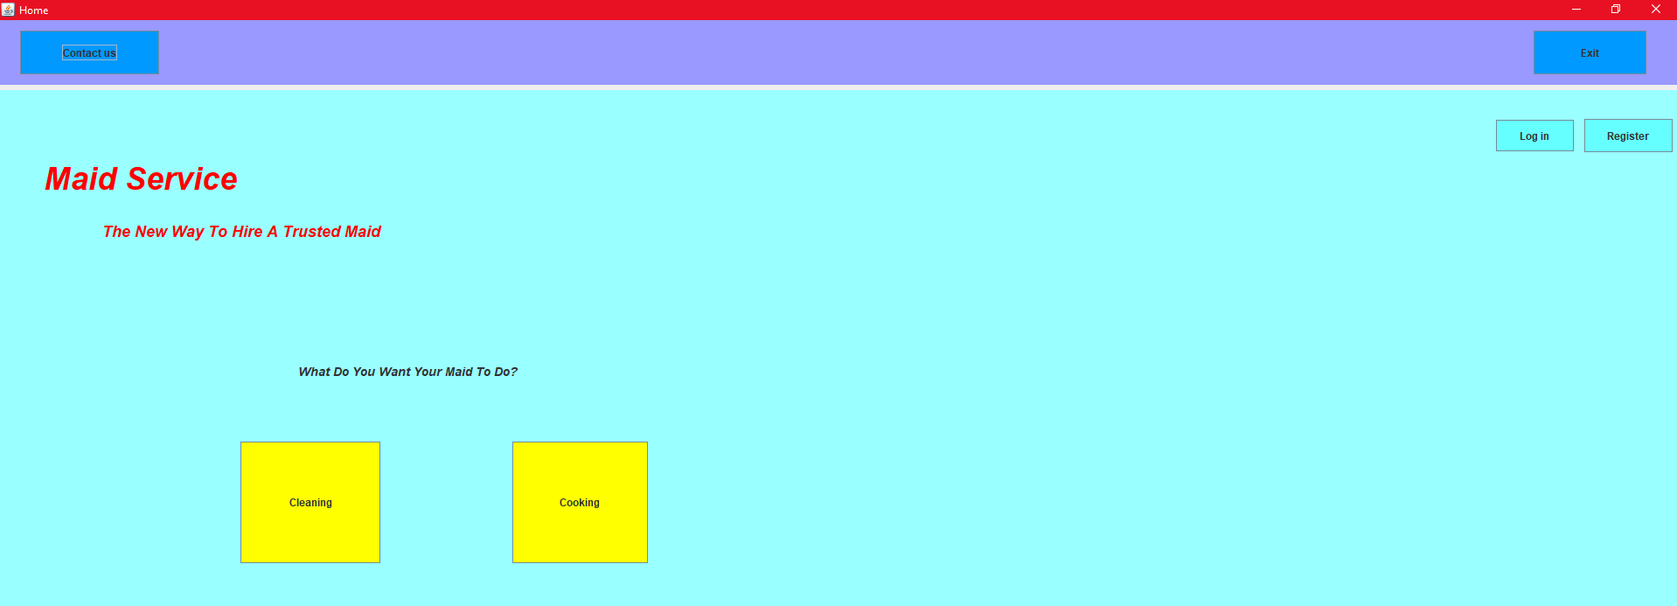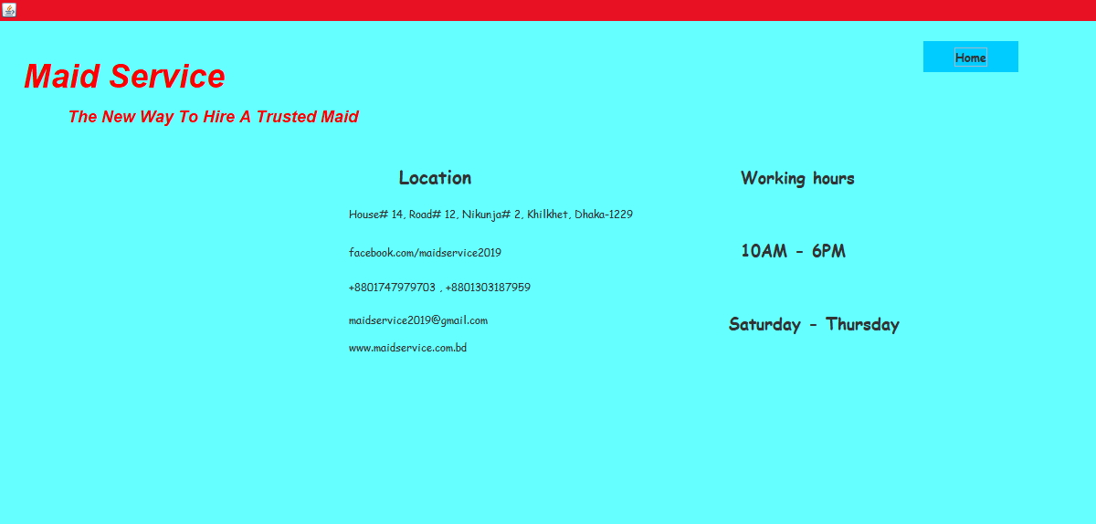

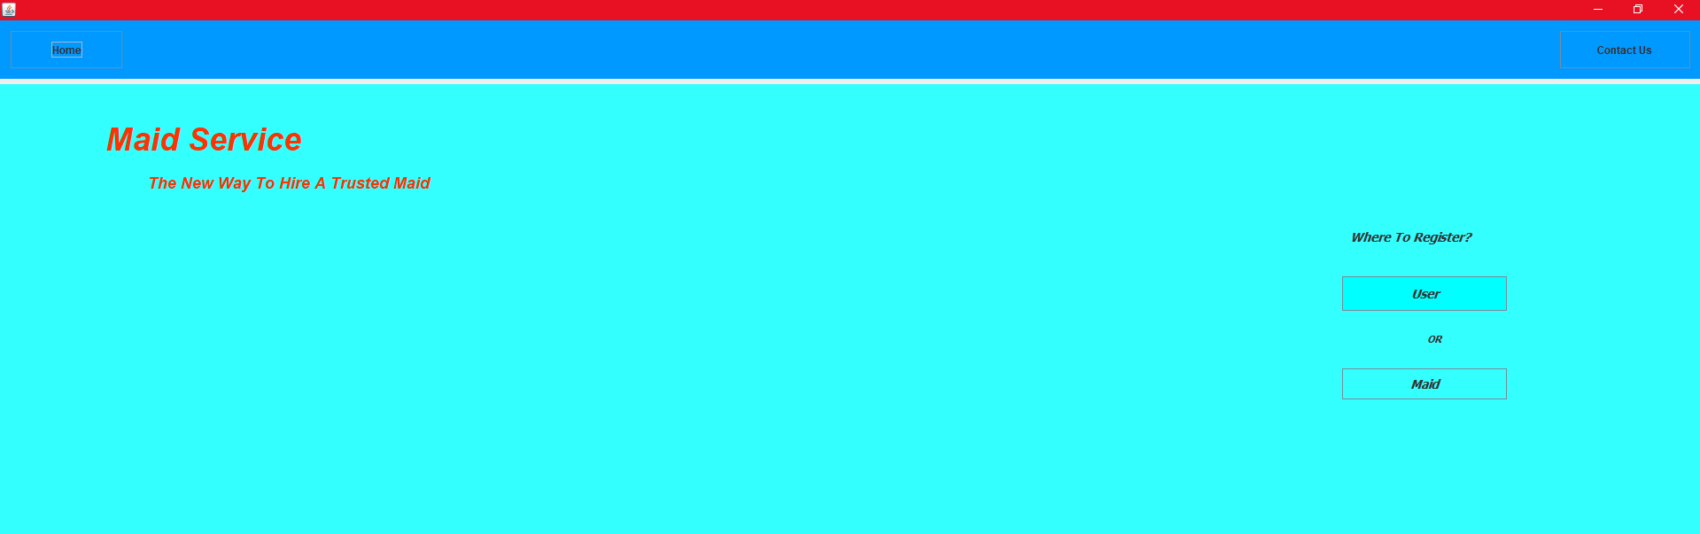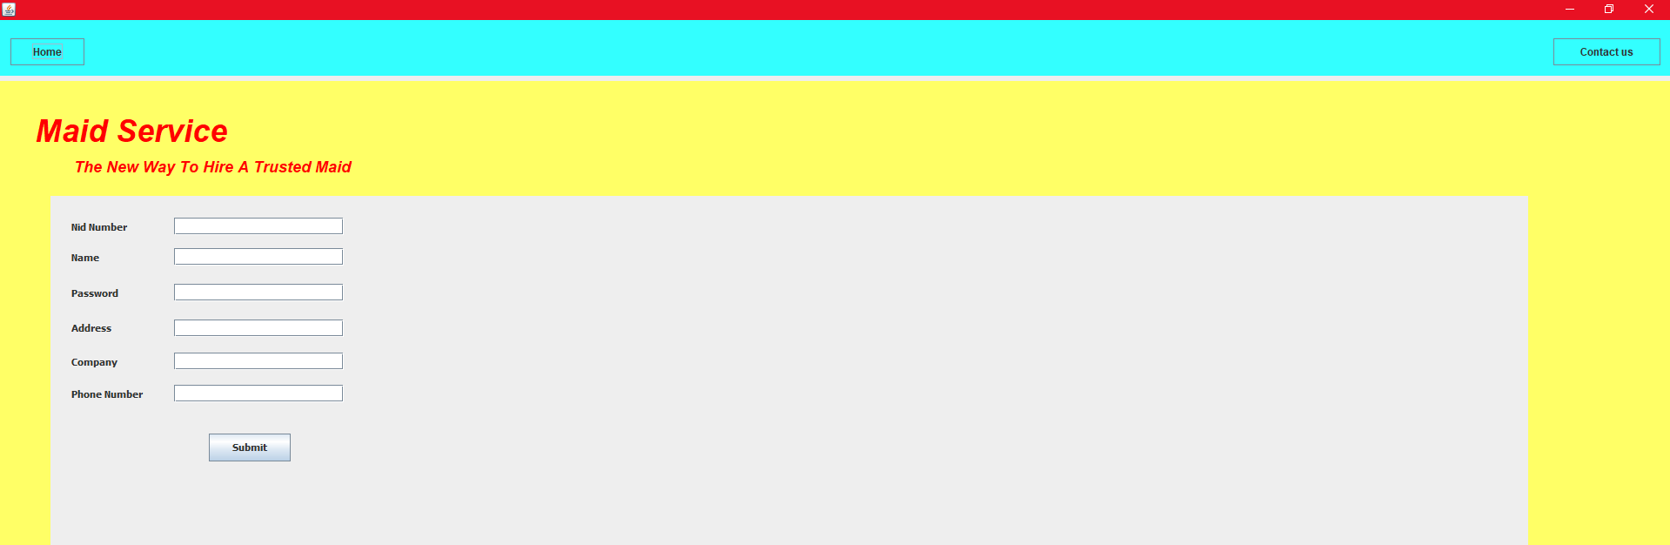

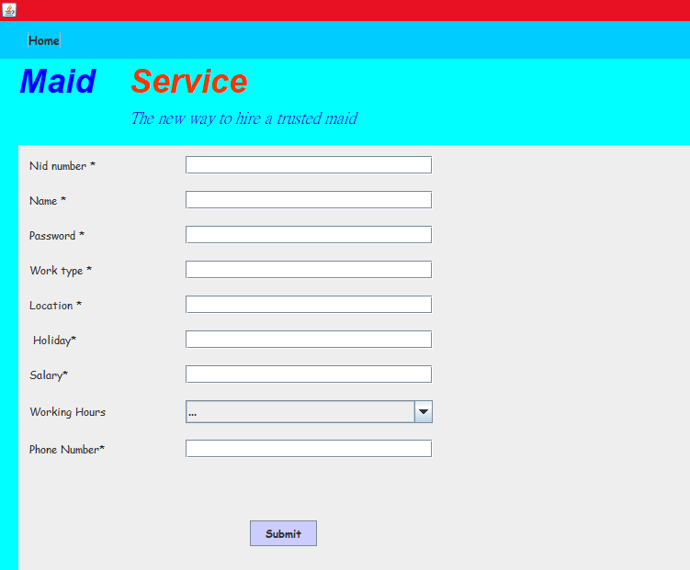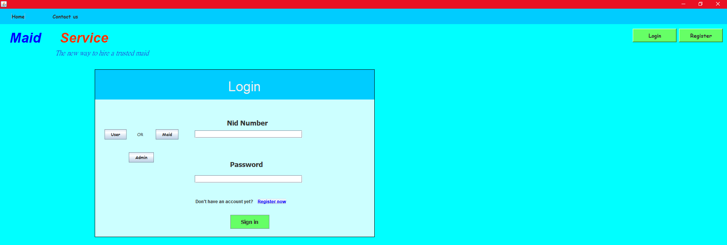

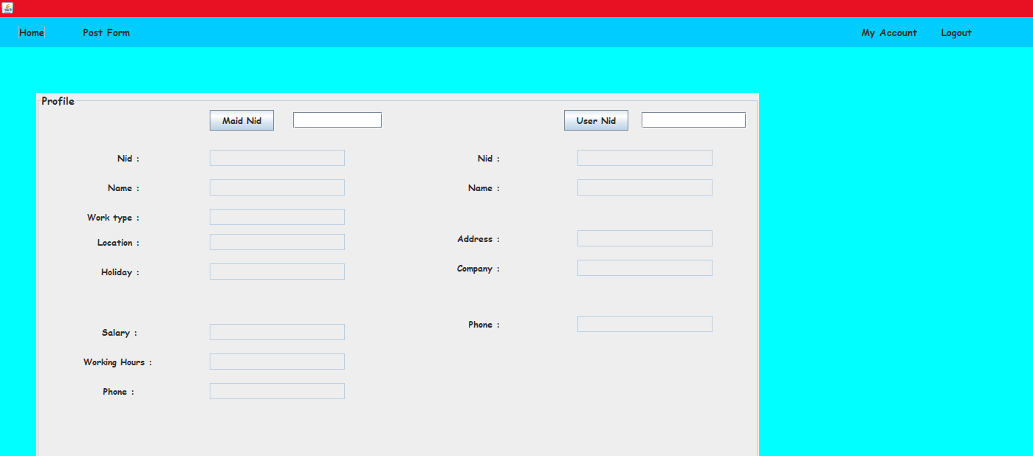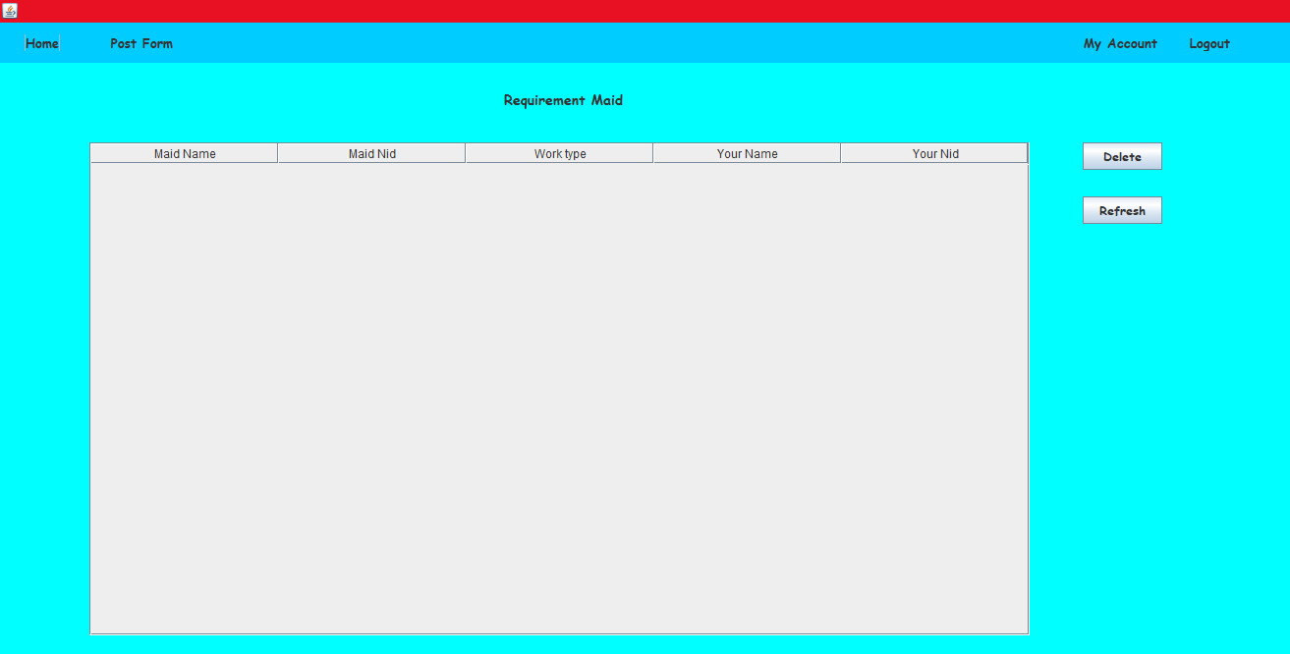

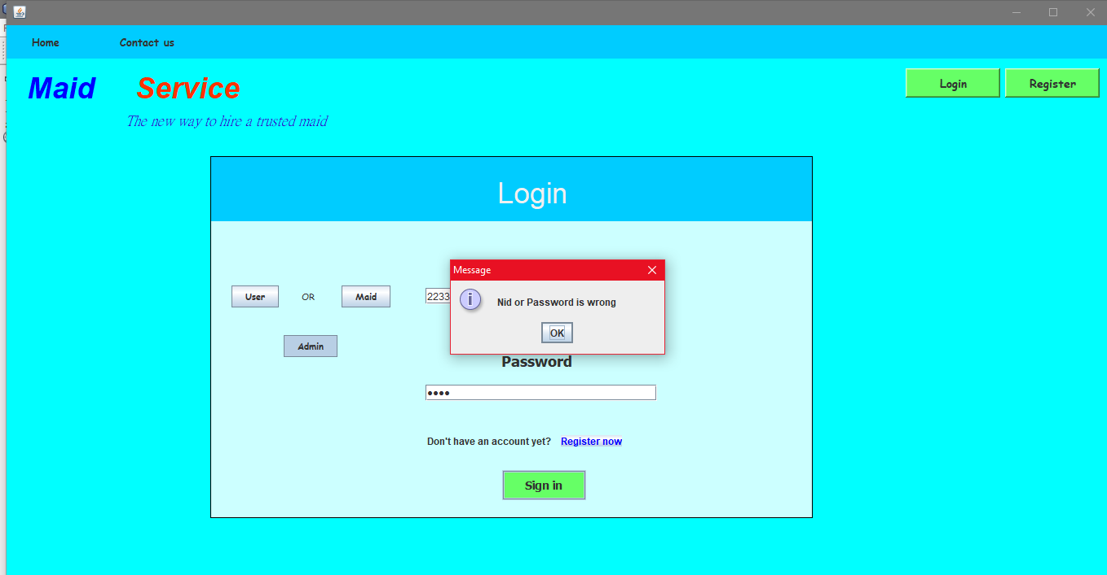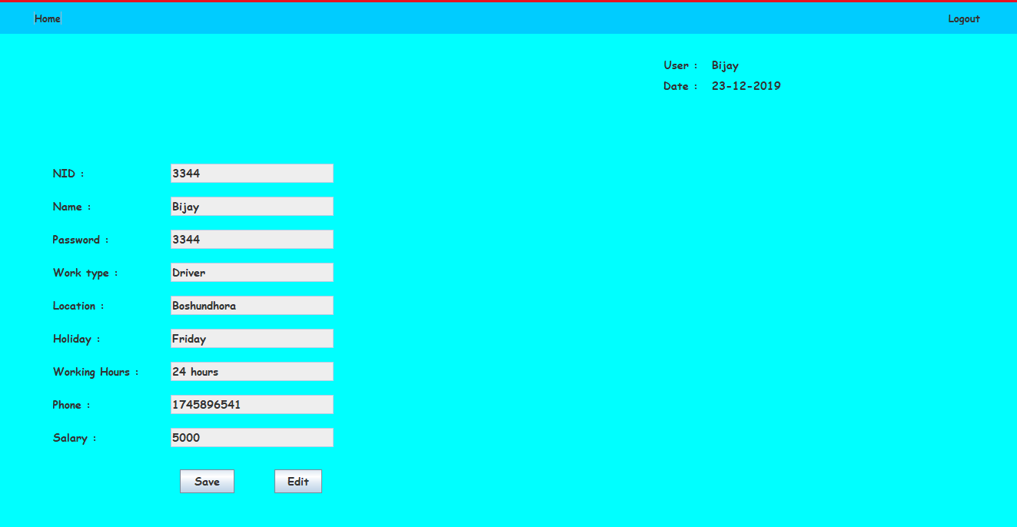

**Database Table Description:**

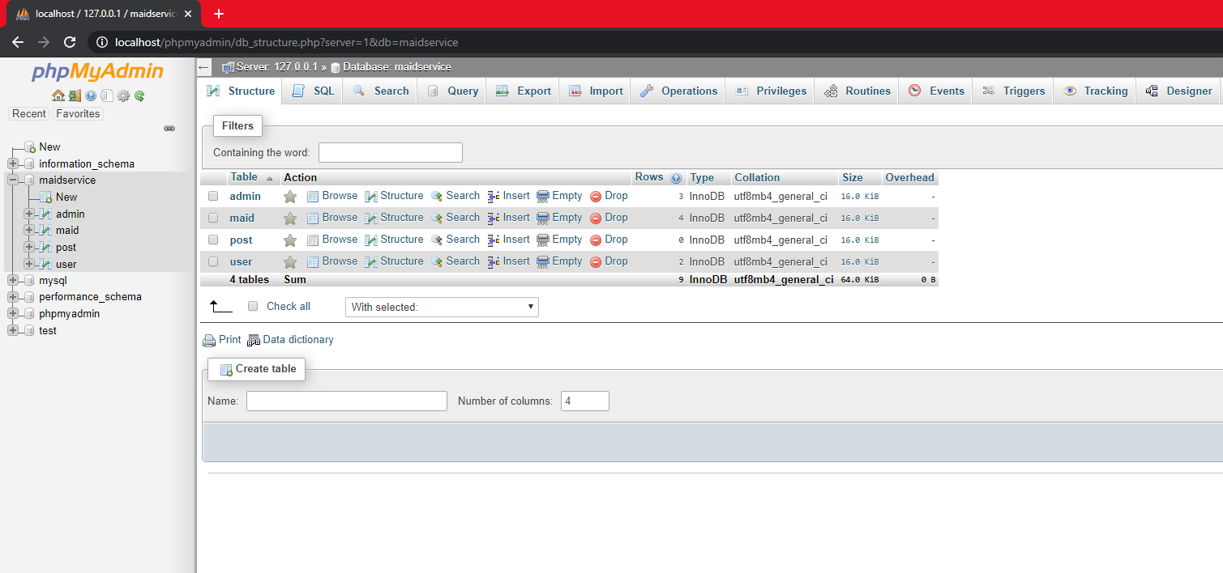

**Class Diagram:**

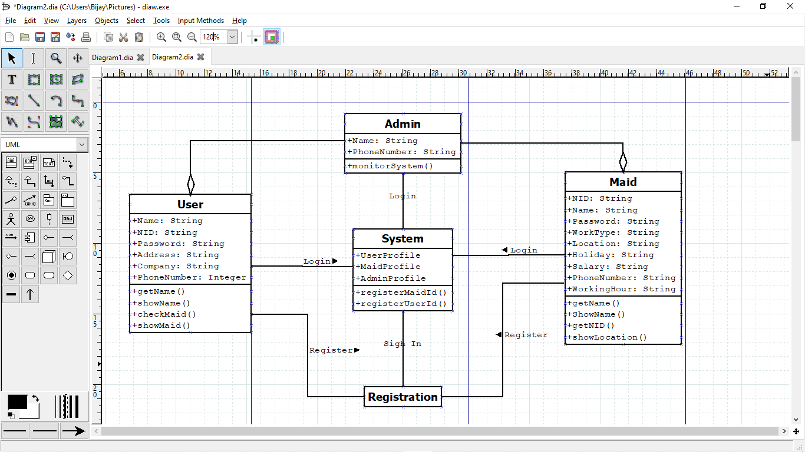

**Tools Used:**

To develop this project we have used the following:

* Net Beans
* JDK
* Xampp
* mysql
* Dia

**OOP and Java Concepts Used:**

* Override
* Graphical User Interface
* Polymorphism

**Impact of this Project:**

In modern age people do not have enough time for their house work. So, they need a person to take care of their houses. But the lack of communication and trust they cannot hire anyone. Online Maid Service can provide maid whom they can trust. Beside that they can easily communicate with the maid informer. They can hire maid according to their available time.

**Limitations and Possible Future Improvements:**

There is a chance of maid harassment which is the limitation of the project.

We can improve the security and harassment issue in the future.